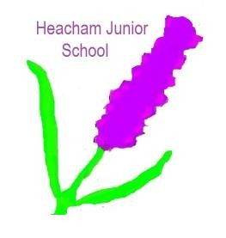
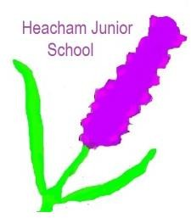
Year 4

Homework Challenge – Autumn Term 2 2025
We would like children to select at least one of the homework challenges below for this term, however children can do as many as they wish. This will continue to be run alongside the regular reading, Maths and English homework that are set.

History – Crime and Punishment  Rules Then and Now (Writing)  Rules help keep everyone safe and happy. Think about the rules we have today, and what rules people might have had a long time ago.  - Name one rule your family or  school has today:  Today's Rule:  - Imagine you are in an old castle. What do you think would have been a very important rule in the castle a long time ago? (Hint: Think about  protection or respect for the King/Queen!)  Old Rule: | Science – The Human Body This task will help you learn about some of the amazing things your body can do!  Body Fact File (Drawing & Writing) Your body is like the most complicated machine ever! Pick one of these body systems or parts and create a small fact file about it on a piece of paper.  Choose one:  - Skeleton/Bones  - Muscles 💪  - Heart & Blood ❤️  - Brain 🧠  - Lungs | Geography – Mediterranean Europe  Choose ONE to make:  Mini Pizzas (or Pittas): Use a pre-made pitta bread, tortilla, or English muffin as a base. Spread on a little tomato sauce, then add "sunshine toppings" like chopped peppers, sliced tomatoes, basil leaves, and a sprinkle of cheese. Bake until golden (with adult help).  Greek Salad Skewers: Thread chunks of cucumber, cherry tomatoes, cubes of feta cheese, and black olives onto a small stick or skewer. Drizzle a tiny bit of olive oil over them.  Hummus Dippers: Prepare some ready- made hummus (or use a simple recipe). Slice up sticks of carrot, cucumber, and bell peppers for dipping.
RE – The Christmas Story  Create a storyboard for the nativity story.  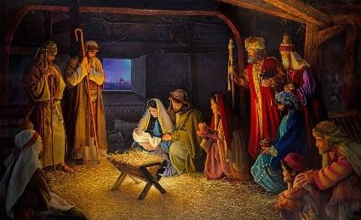 | Art – Take One Picture  Create a unique piece of artwork using paint, coloured pencils, chalks, pastels… anything you have at home! | Maths  Learn your 6 and 7 times table until you know them off by heart and can recite them in class.

The challenge work is due Monday 15th December 2025 and we will spend time looking at and celebrating their work. The above menu details a range of work for the subjects that your child will cover this term.

Children can think about how they would like to present their work. ICT is always acceptable!

It would be nice if the children have a go at this homework so they all have something to share at the end of each half term. We thank you for your continued support.
Part of


