Year 6
Homework Challenge – Autumn Term 2 2025

We would like children to select at least two of the homework challenges below for this term, however children can do as many as they wish. This will continue to be run alongside the regular reading, maths and English homework that are set and we also encourage the children to use SATs Companion and Times Tables Rockstars which have been purchased for them. We also look forward to them continuing to attend to early morning SATs booster club from 8:15 on Tuesdays and Fridays.

History – The Suffragettes  Create an advert for a suffragette campaign.  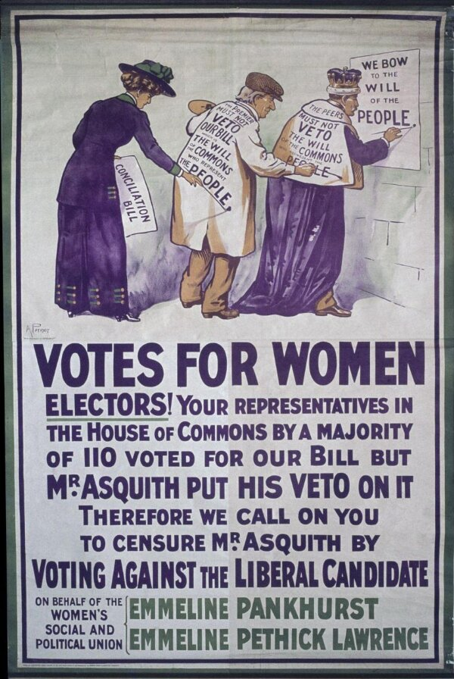  Write a speech for a key figure in the suffragette movement. | Science – Classification of Living Things  Research how animals are classified and present this in an interesting way.  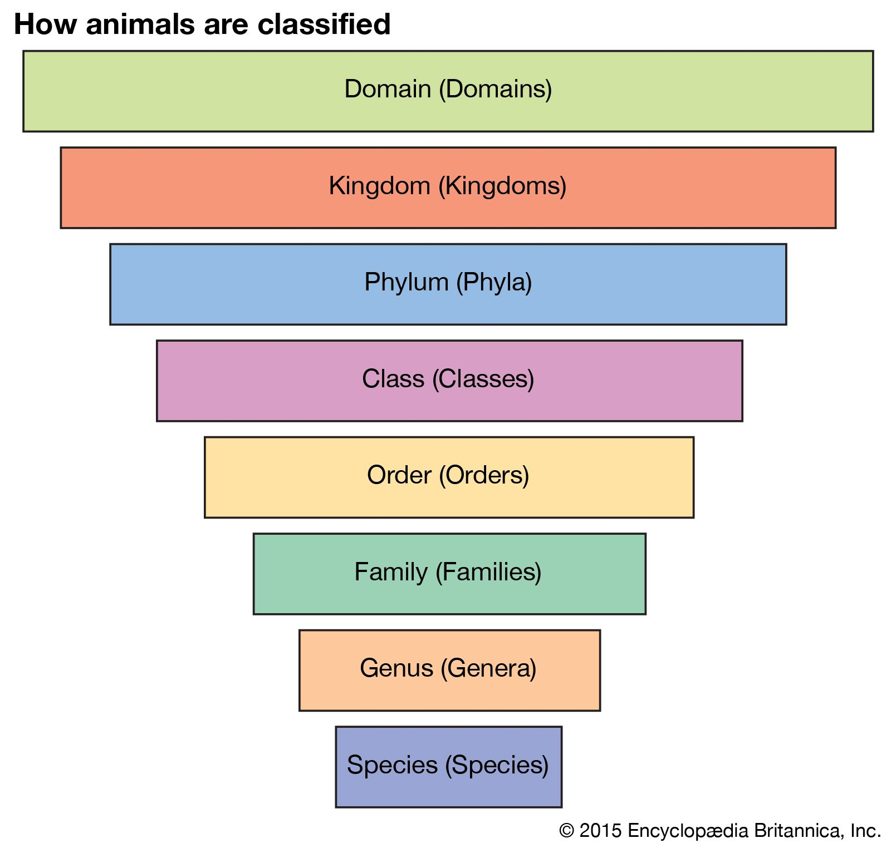  Create an information poster about one of the kingdoms of life. | Geography – North America  Create a holiday brochure to somewhere in North America.  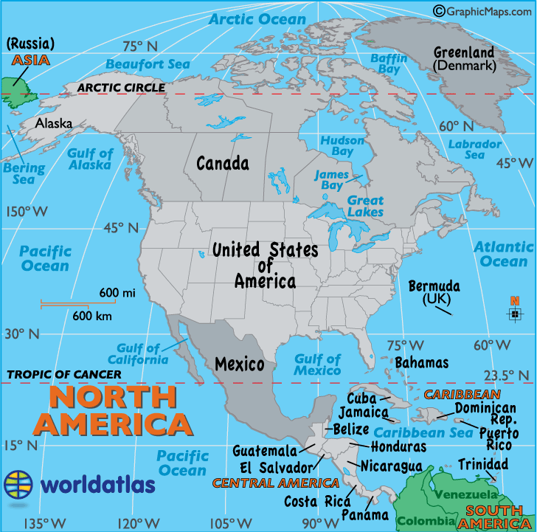  Pick two places in North America and compare them. How could you present this?
RE - Do Christmas celebrations and traditions help Christians understand who Jesus was and why He was born?  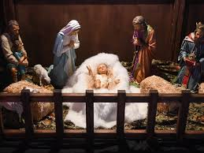  Research Christmas traditions. | Art – Italian Renaissance  Find out Italian Renaissance art and present your information as booklet.  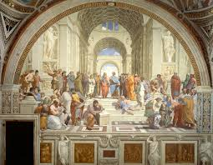  Copy a piece of renaissance art using any medium. | PSHE – Celebrating Differences  Create a poster for our school which celebrates differences and promotes the fact that we are all kind and tolerant of each other.  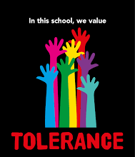  Createa a jigsaw puzzle piece which celebrates you and what makes you unique.

The challenge work is due in 12th December and we will spend time looking at and celebrating their work. The above menu details a range of work for the subjects that your child will cover this term. Children can think about how they would like to present their work.

