Albatross Class – Autumn Home Learning Challenges
We are so excited to welcome you all back and what an excellent start to the year. Over this half –term we would like you to choose some of the following activities to complete. Please choose at least one of these to complete and bring in the evidence by Friday 24th October.
History – Baghdad 900CE  Write a diary entry as if you are a child living in Baghdad in 900CE. Describe the markets, schools, and busy streets.  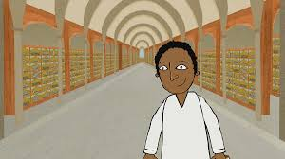 | Science – The Human Body  Recreate a model of a human body. You can use any materials you want like pasta, clay or beads! Make sure to label all the parts.  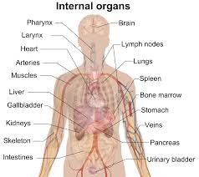 | Geography – Spatial Sense  Find a map of Heacham. Create your own symbols for places you think are important and annotate your map with your symbols. Don’t forget a key!  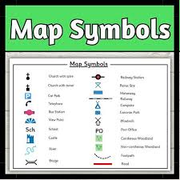 | Computing – Systems. Explore the different systems in your home and create a poster about how it works and how it helps you and your family.  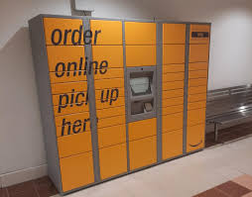
Art – Islamic Art and Architecture  Design your own Islamic building. Think about the patterns we are exploring in art and research already existing architecture to help inspire you.  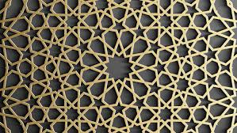 | Maths - Place value  Create a poster showing all the different ways you could represent 137,973. This about place value charts, part-whole models and counters.  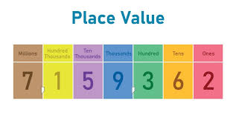 | RE – Islam- Why is Muhammad (PBUH) important to Muslims  Pick one of the stories from the Quran about Muhammad create your own retelling through writing or creating a play  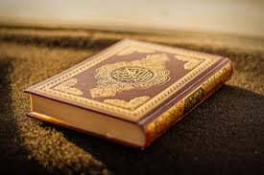 | English – Explanation text  Write an explanation about your favourite hobby. Explain why people enjoy doing it, a bit about its history and how other people can get into it.  