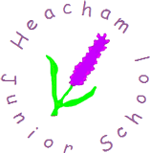
Year 6
Homework Challenge – Spring Term 1 2026

We would like children to select at least one of the homework challenges below for this term, however children can do as many as they wish. This will continue to be run alongside the regular reading, spelling, maths and SATs Companion that are set.

History – Hitler and the Nazi Party    Write a speech for Winston Churchill to read when he becomes PM. You need to motivate the British public to keep fighting against Nazi Germany. | Science – Plants  Conduct an experiment at home to investigate how plants grow.    Link Science and Art and sketch a flower or plant found in your home or garden. | Geography – South America  Create a travel brochure for somewhere in South America.  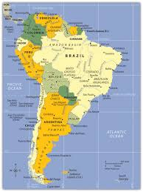
English – Using the text ‘Call of the Wild’  What can you find out about the Klondike Gold Rush?  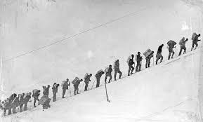  Research North America – the Klondike and region of the Yukon and write a diary about being there. | DT – Dyson Engineering    Can you create a design for a brand new device for the home? It could be something to help with household chores. | PSHE – Dreams and Goals  Write a letter to yourself in the future.    Write a letter of application for your dream job about why you would be suitable.

The challenge work is due in on Wednesday 11th February and we will spend time looking at and celebrating their work. The above menu details a range of work for the subjects that your child will cover this term. Children can think about how they would like to present their work.

It would be nice if the children have a go at this homework so they all have something to share at the end of each half term. We thank you for your continued support.

