Year 4
Homework Challenge – Autumn Term 1 2026

We would like children to select at least one of the homework challenges below for this term, however children can do as many as they wish. This will continue to be run alongside the regular reading and Maths practice for the MTC.

History – Anglo Saxons, Vikings and Scots.  Create a "Who Would You Rather Be?" Poster  Imagine you could travel back in time and live as either an Anglo-Saxon, a Viking, or a Scot.  - Explains what life would be like for each group.  - Includes at least 3 facts about each group. | Science – Cycles in Nature  Make a fact-file or poster about the life cycle of your favourite plant.  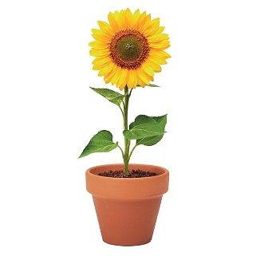 | Geography – Spatial Sense  Draw a large-scale map of your local area. You could include your route to school, parks, beaches, woods etc.  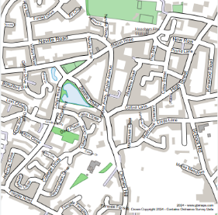
RE - Buddhism: Is it possible for everyone to be happy?  Create a poster, booklet, or presentation called "My Guide to Happiness."  Include:  - 3 things that make you happy.  - 3 ways Buddhists try to find happiness. | Art – Light  Create a fact file about a famous artist who used light in their artwork.  Choose from –  Caravaggio, Claude Monet, and James Turrell. | PSHE/Computing  Create a PowerPoint presentation all about yourself on the computer!

The challenge work is due Monday 20th October 2026 and we will spend time looking at and celebrating their work. The above menu details a range of work for the subjects that your child will cover this term.

Children can think about how they would like to present their work. ICT is always acceptable!

It would be nice if the children have a go at this homework so they all have something to share at the end of each half term. We thank you for your continued support.

