Albatross Class – Autumn Home Learning Challenges
We are looking forward to another half term of excellent learning!. Over this half –term we would like you to choose some of the following activities to complete. Please choose at least one of these to complete and bring in the evidence by Friday 19th December.
History – The Birth of the British Empire  Find or create a map. On it, annotate the countries that have been part of the British Empire, including the dates they were part of the Empire.  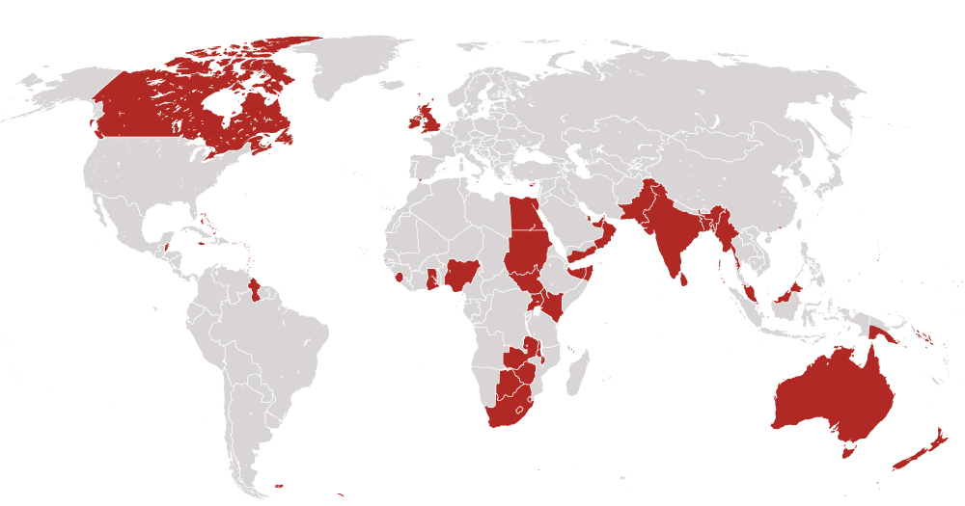 | Science – Chemistry  Create your own poster of the periodic table of elements. Use different colours to show the different groups.  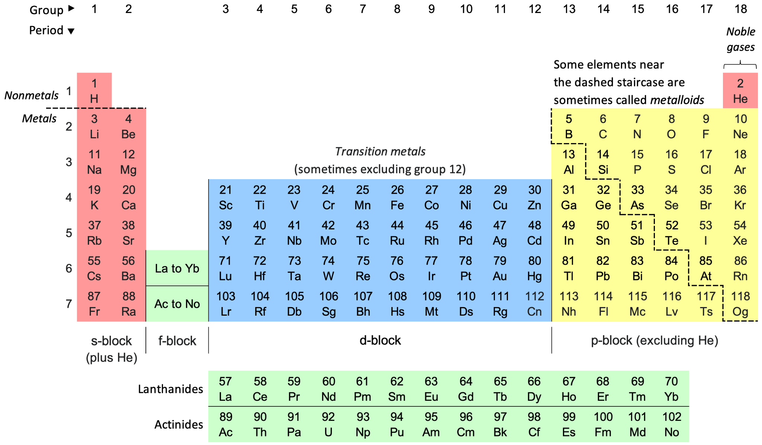 | Geography – Mountains  Create a fact file on one mountain found in the world. Include a map of where it is, information on how tall it is, its estimated age and how many people visit it.  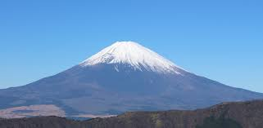
Art – African Art  Research traditional African art work. Find a piece that you like and recreate it using the materials that you have available at home.  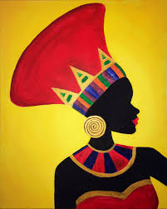 | Maths - Fractions  Create a project showing how fractions appear in real life by using pictures, numbers, and words to explain at least five examples. Include some equivalent fractions and present your work neatly as a poster, booklet, or digital presentation.  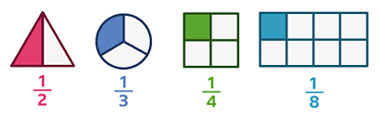 | RE – Is the Christmas story true?  Story board the different events of the Christmas story. Make sure to include both pictures and captions to explain what is happening.  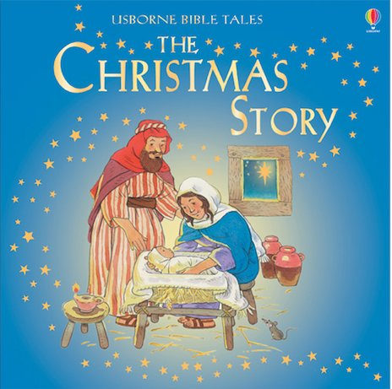 | English – Portal Stories  Write your own story, imagining that your main character has stepped through a portal. Focus on a beautiful setting description and an exciting adventure.  

