Year 4
Homework Challenge – Autumn Term 1 2025

We would like children to select at least one of the homework challenges below for this term, however children can do as many as they wish. This will continue to be run alongside the regular reading, Maths and English homework that are set.

History – Tudors  Create your own wall painting (on paper) of Henry VIII.  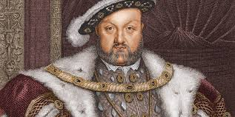 | Science – Cyles in Nature  Make a fact-file or poster about the life cycle of your favourite plant. | Geography – Spatial Sense  Draw a map of your local area. You could include your route to school, parks, beaches, woods etc
RE - Buddhism: Is it possible for everyone to be happy?  Create your own story about someone who has no money but is very happy and another character that has lots of money but is never happy. Why is this? This could be handwritten, typed on a computer, illustrated or even a comic strip! | Art – Monuments of Byzantine  Use symmetry to create a mosaic out of scrap paper at home.  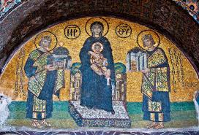 | PSHE/Computing  Make a factfile about yourself – handwritten or use ICT

The challenge work is due Monday 20th October 2025 and we will spend time looking at and celebrating their work. The above menu details a range of work for the subjects that your child will cover this term.

Children can think about how they would like to present their work. ICT is always acceptable!

It would be nice if the children have a go at this homework so they all have something to share at the end of each half term. We thank you for your continued support.

