Year 4
Homework Challenge – Autumn Term 2 2026

We would like children to select at least one of the homework challenges below for this term, however children can do as many as they wish. This will continue to be run alongside the regular reading and Maths practice for the MTC.

History – Henry VIII and The Tudors  Create an eye-catching poster all about Henry VIII and the Tudor period.  Include:  - At least 5 facts about Henry VIII.  - Information about Tudor life (homes, food, clothes, schools, or jobs).  - A picture or drawing of Henry VIII and/or a Tudor scene.  You can present your work as a poster, booklet, leaflet, or digital presentation. 👑🏰📜 | Science – The Water Cycle  Create a Water Cycle Model or Poster  Show how water travels around the Earth in a continuous cycle.  Include:  - Evaporation  - Condensation  - Precipitation  - Collection  Label each stage and use arrows to show the journey of water. | Geography – Western Europe  Create a Western Europe Travel Brochure  Imagine you are a travel guide promoting Western Europe.  Include:  - A map showing at least 5 countries in Western Europe.  - The capital city of each country.  - One famous landmark, food, or cultural fact for each country.  - Pictures, drawings, or flags to make your brochure attractive.
RE – Christianity – Christmas  Create a booklet that retells the Christian story of the first Christmas.  Include:  - The Angel visiting Mary.  - The journey to Bethlehem.  - The birth of Jesus.  - The shepherds visiting Jesus.  - The Wise Men bringing gifts. | Art – Space  Use the art element of space to create a picture that shows objects at different distances.  Your artwork should include:  - Something in the foreground (closest to the viewer).  - Something in the middle ground.  - Something in the background (furthest away).  - Overlapping objects to create a sense of depth. | PSHE/Computing  Take a photo and edit it in any way you can!  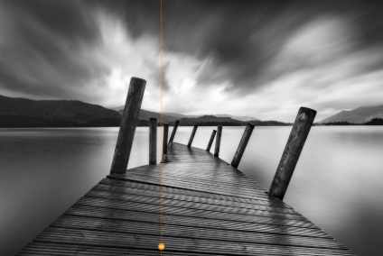

The challenge work is due Monday 15th December 2026 and we will spend time looking at and celebrating their work. The above menu details a range of work for the subjects that your child will cover this term.

Children can think about how they would like to present their work. ICT is always acceptable!

It would be nice if the children have a go at this homework so they all have something to share at the end of each half term. We thank you for your continued support.

