Year 6 – Royal Terns
Homework Challenge – Autumn Term 1 2026
We would like children to select at least two of the homework challenges below for this term, however children can do as many as they wish. This will continue to be run alongside the regular reading, maths and English homework that are set and we also encourage the children to use SATs Companion which has been purchased for them.
History – WW1  Find out about the significance of the poppy and create some poppy inspired art.  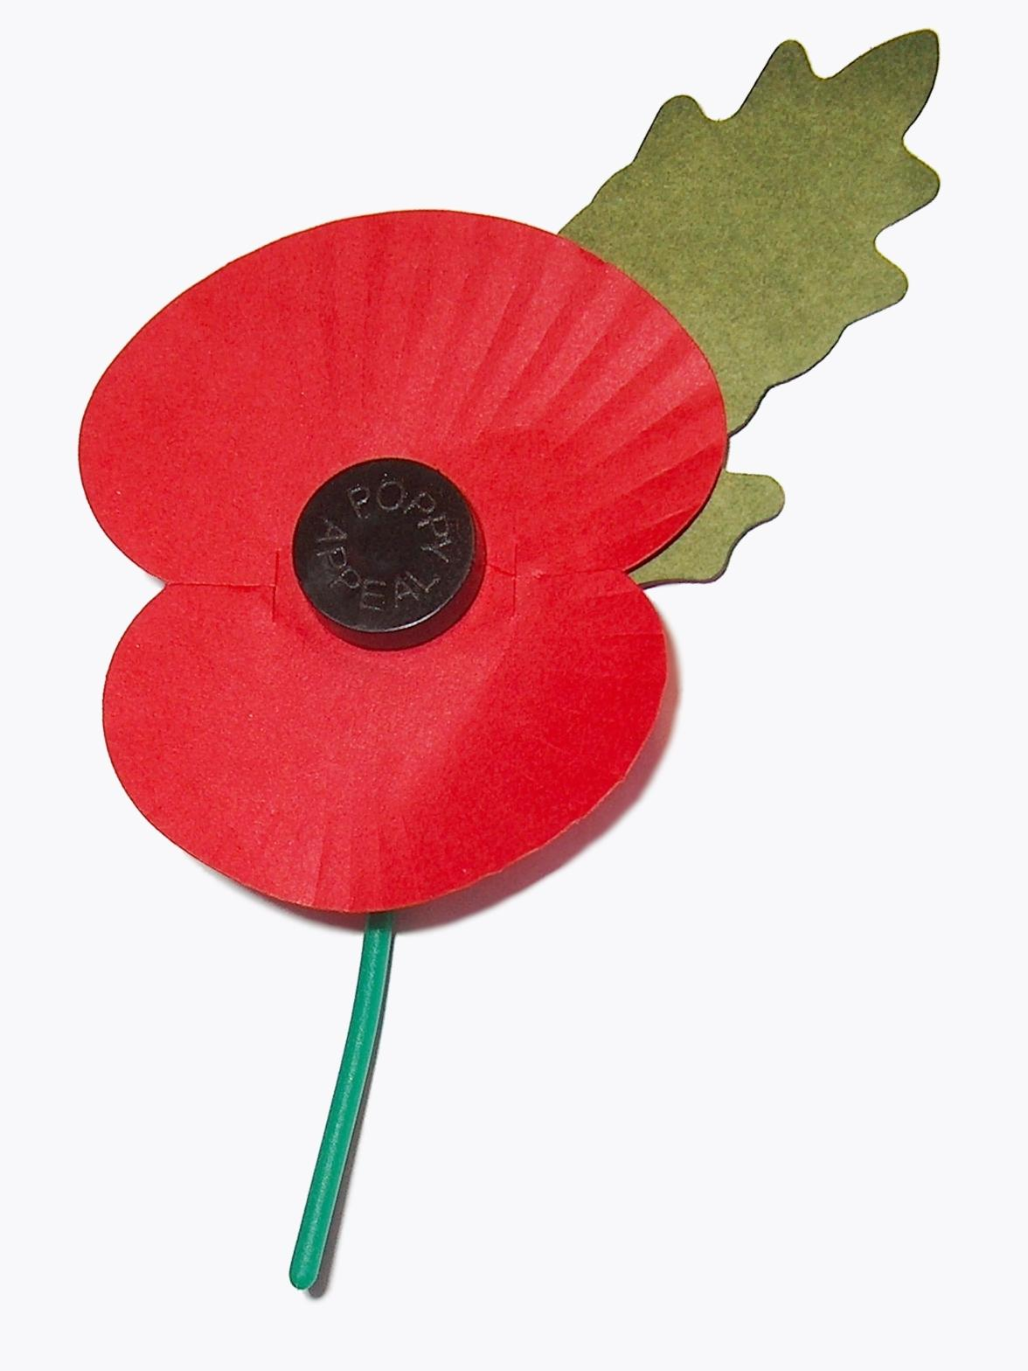  Write an essay about life in the trenches. | Science – Chemistry  Create a 3D model of an atom  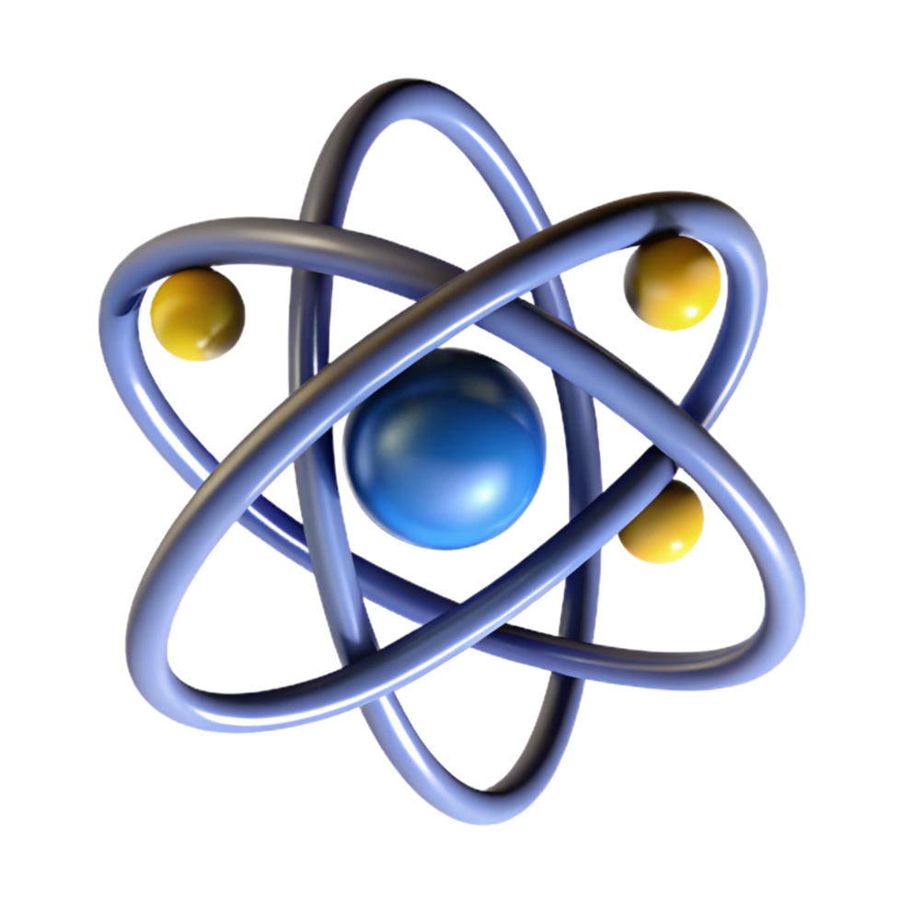  Find out about the life of a famous scientist and create a fact file or write a biography or autobiography about theur life. | Geography – Spatial Sense  Design an information poster all about time zones and how they work.  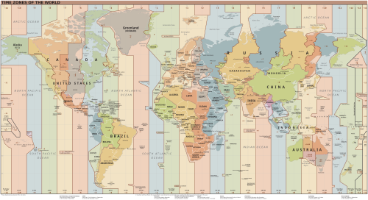  Create a drawing or painting of the landscape in America. (This will help with our topic next half term.)
Computing  Design an poster to promote esafety.  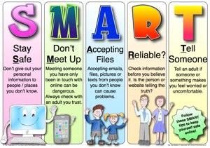  Write a set of esafety rules that could be shaed with all children in the school. | Art – William Morris  Design your own William Morris print.  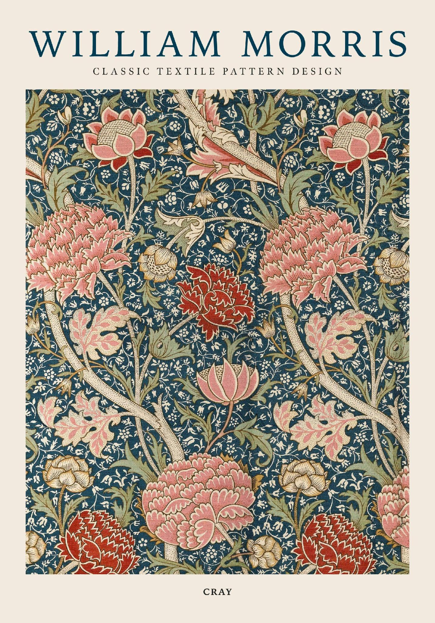  Create a William Morris inspired collage. | PSHE – Being Me  Write an autobiograophy about your life so far.    Draw a self portrait or create a piece of 3D art to represent yourself. Make sure you can talk about it.
The challenge work is due in 22nd October and we will spend time looking at and celebrating their work. The above menu details a range of work for the subjects that your child will cover this term. Children can think about how they would like to present their work.
It would be nice if the children have a go at this homework so they all have something to share at the end of each half term. We thank you for your continued support.

