

hHEACHAM JUNIOR sSCHOOL

NEW STARTER GUIDANCE PACK

2025/2026

College Drive

Heacham

King’s Lynn

Norfolk

PE31 7EJ

01485 571013

office@heachamjunior.co.uk
www.heachamjunior.co.uk

Welcome message from our Executive Headteacher

“Love of Learning, Bright Futures, Happy Memories”

Welcome to our school. Our friendly, inclusive junior school, which is situated in a large village on the West Norfolk coast, just a short walk away from our Infant School, which shares the same families, leadership team and curriculum. We also partner with Snettisham Primary School, which is a thriving village school 2 miles along the coast. As a team, we work together with you and your children in order to create the best opportunities for your child’s future. We are proud to belong to West Norfolk Academies Trust, as we know that collaboration plays an important part in delivering the best education to our pupils and families.

We deliver a knowledge-rich curriculum, written by our staff that is ambitious and broad in its variety and scope. Our pupils learn specific knowledge that supports their progress and enjoyment. Our curriculum is enriched with opportunities to develop spiritual, moral, cultural and social skills suitable within our modern British Values. Our behaviour policy encourages respect, belonging, tolerance, kindness and thoughtfulness into all our pupils. It also means that we value and celebrate the differences between us. Our curriculum also raises our young children’s aspirations and broadens their horizons through links with the wider community and world.

We have great facilities at our school, including extensive grounds, which house a trim trail, amphitheatre, outdoor classroom and pirate ship! We plan trips, visits and workshops every term to make learning fun and offer a good range of enrichment activities. Good achievement, happiness and good behaviour are our priorities with good care and guidance from our dedicated staff and governors.

There are also many opportunities for you to come and help. So please come to visit us and see for yourselves what we can offer your children in our vibrant school.

Ms. Louise Jackson
Executive Headteacher


We are proud members of
West Norfolk Academies Trust

School Leadership Team




Louise Jackson Ashley Kirwan
Executive Headteacher Assistant Headteacher

Our Current Class Structure

Year 34 Oystercatcher

Year 4 Avocet

Year 5 Albatross

Year 6 Royal tern

Information for Parents

Uniform
Embroidered school uniform can be purchased from Minuteman Press in King’s Lynn 01553 661103, kingslynn@minutemanpress.com.

Uniform consists of charcoal grey skirt, trousers or pinafore. Sky blue polo top, burgundy sweatshirt/cardigan, burgundy fleece – all with school logo. In the summer, blue check dresses and charcoal grey tailored shorts are permitted. Children should wear black school shoes (trainers or boots are not permitted). PE kit consists of sky blue t-shirt with school logo, navy blue or black shorts, navy blue or black tracksuit, trainers for outdoor activity and plimsolls or bare foot for indoor. Stud earrings are the only jewellery permitted and must be removed for PE and swimming.

Please label all belongings!

School Dinners and Packed Lunches
School dinners are £2.60 per day. We operate a cashless system using MyChildAtSchool. We will set up an account for you once your child is registered. Details will be sent home with your login details. If you think you may be entitled to Free School Meals, please complete and return the application in this pack or complete online at www.norfolk.gov.uk/neo. Our food is cooked onsite and provided by Lunchtime Co., a sample of their menu is enclosed.

Packed Lunches should be healthy. We are very waste conscious and encourage the use of reusable containers. Please include a drink (not fizzy please). Children are also permitted to have a water bottle for use in the classroom (squash/juices are not permitted in the classroom) this should be taken home each day to be cleaned/refilled.

Please let us know if your child has any food allergies or intolerances.

Keeping in touch with parents
CLASS DOJO – This is our main communication tool. We share pictures and documents as well as listen upcoming events.
EMAIL – We often send notifications, letters and copies of paperwork etc. via email. Please ensure that you give us your email address on the forms enclosed.
X – We have a page on X were we share events and photos.
WEBSITE – You can access lots of parental forms, information and also our events calendar on our website www.heachamjunior.co.uk.
MCAS – MyChildAtSchool is the parent portal to our MIS system Bromcom. You can view attendance, book clubs and trips and order lunches and update your contacts.

Home Learning and Class Dojo
We want home learning to be a positive experience for pupils, lined as closely as possible to classroom work and our knowledge-rich curriculum. Home learning allows parents, carers and the school to work in partnership for the benefit of the child with regards to learning and wellbeing. The purpose will be to reinforce skills which have been taught in school, promote new learning and use a variety of online resources to support leaning and communicate with parents and pupils. We use the Class Dojo platform. Your child’s teacher will upload homework to Class Dojo each week. A Class Dojo account name and password will be issued to your child once they start with details on how to log in and use the app. We also recognise that all children need leisure and wellbeing time and encourage a balance between consolidating learning and enrichment activities.

Absence and our Safeguarding Responsibilities
Research commissioned by the Department for Education shows missing school for even a day can mean a child is less likely to achieve good grades, which can have a damaging effect on their life chances. At Heacham Junior School our aim is to work with parents to ensure that all our pupils receive the most from their education and reach their full potential.

The Government remains very clear that no child should miss school apart from in exceptional circumstances and schools must continue to take steps to reduce absence to support children’s attainment.

In the DfE policy document entitled, ‘School Attendance: Guidance for maintained schools, academies, independent schools and local authorities’ it states, ‘Head teachers should not grant leave of absence unless there are exceptional circumstances. The application must be made in advance and the head teacher must be satisfied that there are exceptional circumstances based on the individual facts and circumstances of the case which warrant the leave. Where a leave of absence is granted, the head teacher will determine the number of days a pupil can be away from school. A leave of absence is granted entirely at the head teacher’s discretion’.

The Government have introduced a single national threshold for when a penalty notice must be considered by all schools in England. This threshold is 10 sessions (usually equivalent to 5 school days) of unauthorised absence within a rolling 10 school week period. These sessions do not have to be consecutive and can be made up of a combination of any type of unauthorised absence. The period of 10 school weeks can span different terms or school years.

Reporting your child’s absence
It is a legal requirement to make contact with a parent daily, to ensure that a child is not presumed to be ill when they have, in fact, walked to school and something happen on the way to prevent them from arriving. Should an incident occur, a whole day would pass before anyone would know that a child is missing. If your child is absent for any reason, please contact school every day. Please either email the office or call, leaving a message if there is no reply.

It is also part of our Safeguarding responsibilities to request and ensure that the school has at least two working contact numbers for children for emergencies.

West Norfolk Academies Trust Privacy Statement
When you or your child registers to become a WNAT pupil, we will need to collect Personal Information from you to enable us to provide our services. This information is often provided directly by you or your parents, guardians or carers and includes Personal Information such as your name, age, address, home telephone number and other information we need to contact you. We may also need to collect information relating to your first language, ethnic and religious background, your nationality at birth and if you are eligible to receive free school meals.
Much of the information we have listed above will come directly from you on your admission application but we may also receive information from your former school as well.
Once you become a pupil at one of our schools we will also begin to collect additional Personal Information such as, assessment data, attendance information, details relating to your behaviour, relevant medical information and if you require any support from us or our specifically selected external educational support partners such as Norfolk County Council.
We only ever collect and use the information that we need to provide you with our educational services such as learning support, providing appropriate pastoral care, monitoring your progress, providing reports regarding your development and assessing the quality of our educational services. We are also obliged by law to collect and share certain Personal Information as part of our legal obligations to provide Census information and fulfil our duties to promote safeguarding and wellbeing of our pupils.
We will inform you if the information we collect is mandatory or voluntary and we will always ensure that a lawful basis exists for processing the Personal Information we hold on your behalf. If we require your consent to process your Personal Information, we will always notify you of your rights and exactly what you are consenting to. If you are volunteering any sensitive Personal Information to WNAT under consent, we will ensure that your consent is given explicitly and all consents you provide will be recorded. Any consent for processing you provide to WNAT can be withdrawn at any time by contacting the dpo@westnorfolkacademiestrust.co.uk
We are required to share information about our pupils with the Department for Education (DfE) under section 5 of the Education (Supply of Information about the School Workforce) (England) Regulations 2007 and amendments. If we share pupil information with any other external body, we will always ensure that a lawful basis exists at all times and the Personal Information is shared under an agreement between WNAT and the receiving body.
More information can be found on our school website.

HEACHAM JUNIOR SCHOOL

College Drive, Heacham, PE31 7EJ

TEL: 01485 571013
office@heachamjunior.co.uk
www.heachamjunior.co.uk

New Starter

Welcome Pack

In this welcome pack you will find:

Document | Who needs to complete and return
Admission Form | All parents
Authorised People to collect | All parents
Digital Images Permission | All parents
Email & Text Permission | All parents
Acceptable Use - Online Safety Policy | All parents
Home-School Agreement | All parents
Regular Offsite Activity Permission | All parents
Forest School Permission | All parents
Free School Meals Application * | Only if applicable
House Allocation | Only if applicable
Special Diet Form & Photo Permission | Only if applicable
Asthma Emergency Salbutamol Permission | Only if child has Asthma
Asthma Letter & Record | Only if child has Asthma
Allergy / Medical Emergency Form | Only if child has Allergy
Attendance Policy | n/a - info only
Lunchtime Co. Example Menu | n/a - info only
Term Dates 2025-2026 | n/a – info only
Uniform Supplier Information | n/a – info only
Prospectus 2025-2026 | n/a – info only

* You can apply online for Free School Meals: www.norfolk.gov.uk/neo

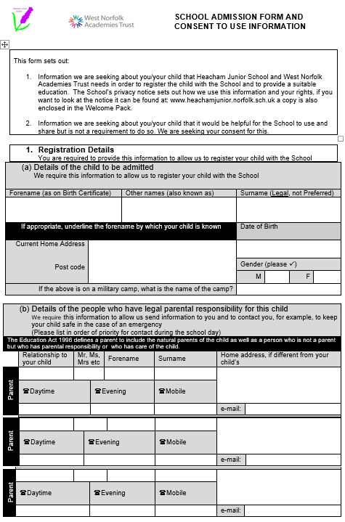
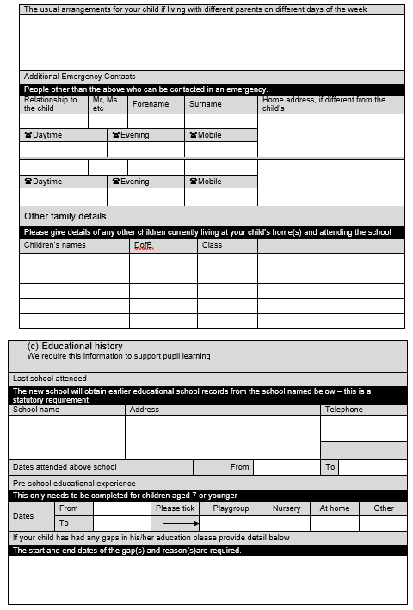

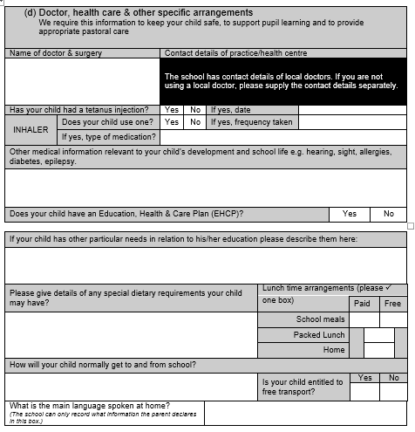

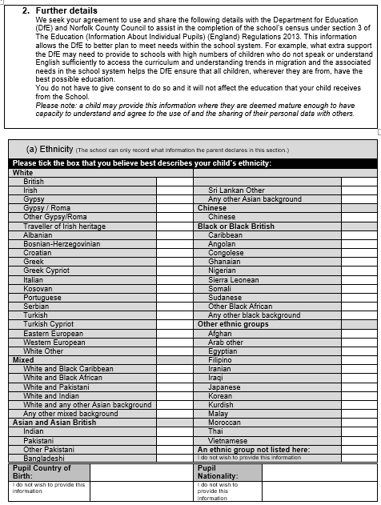

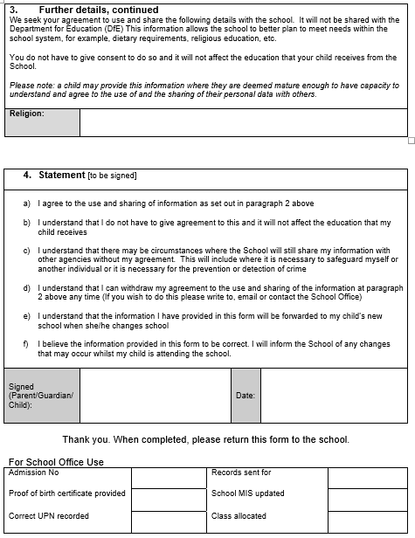
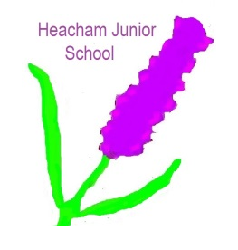

HEACHAM JUNIOR SCHOOL

College Drive, Heacham, PE31 7EJ

TEL: 01485 571013

office@heachamjunior.co.uk
www.heachamjunior.co.uk

AUTHORISED PEOPLE TO COLLECT &
END OF DAY ARRANGEMENTS:

Children in Years 3 & 4 should be collected from the school grounds. The children are escorted by their teacher just after 3.25pm, once they have gathered their belongings, to the concrete area outside the hall (near the trim-trail).

Once children are in Years 5 & 6 they may walk home alone or meet their adult outside the school grounds but only if the school is advised in writing.

I / We authorise the following adults to collect

Name of child: from school at any time.

If there are any changes to this list I will inform the school immediately.

Signed: Date:

NAME RELATIONSHIP TO CHILD

1. _____________________________ ___________________________

2. _____________________________ ___________________________

3. _____________________________ ___________________________

4. _____________________________ ___________________________

5. _____________________________ ___________________________

6. _____________________________ ___________________________

Please note that we need written permission for your child to go home with any person not listed in our records.
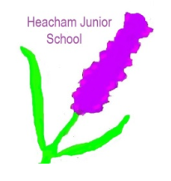

HEACHAM JUNIOR SCHOOL

College Drive, Heacham, PE31 7EJ

TEL: 01485 571013
office@heachamjunior.co.uk
www.heachamjunior.co.uk

Parental/Carer Permission: Use of digital images – photography and video

To comply with the Data Protection Act 2018, we need your permission before we can photograph or make recordings of your daughter/son. We follow the following rules for any external use of digital images:

- If the pupil name is visible, we avoid using their photograph.
- If their photograph is used, we avoid using names or identifying individual children.

Where showcasing examples of pupils’ work we only use their first names, rather than their full names. We will only use pupil first names in credits. Only images of pupils in suitable dress are used.

Examples of how digital photography and video may be used include:

- Your child being photographed (by the classroom teacher, teaching assistant or another child) as part of a learning activity; e.g. photographing children at work and then sharing the pictures through the learning journeys, a projector/on screen in the classroom allowing the children to see their work and make improvements, Class Dojo.
- Your child’s image for presentation purposes around the school; e.g. in school wall displays and electronic presentations to capture images around the school or in the local area as part of a project, lesson or assemblies, on the Television Presentation in Reception.
- Your child’s image being used in a presentation about the school and its work in order to share its good practice and celebrate its achievements, e.g. our school website or the media.

Note: If we, or you, actually wanted your child’s image linked to their name we would contact you separately for permission, e.g. if your child won a national competition and wanted to be named in local or government literature.

Use of digital images - photography and video: I agree to the school using photographs of my child or including them in video material as indicated below. I understand that images will only be used to support learning activities or in publicity that reasonably promotes the work of the school, and for no other purpose.

Please tick Yes or No:
In School (classrooms, corridors, books & folders) Yes [ ] No [ ]
On School website & Social Media (X) Yes [ ] No [ ]
Class Dojo App (only visible to school community not public) Yes [ ] No [ ]
In the School’s newsletter (this is uploaded to our website) Yes [ ] No [ ]
In the local press (Image only, no names) Yes [ ] No [ ]
Schools’ Sports Partnership website Yes [ ] No [ ]

Child’s Name:

Parent / carer signature: _____________________________ Date: _____/_____/_____

HEACHAM JUNIOR SCHOOL
Email & Text Permissions

We try hard to keep you informed. We email frequently to keep you up to date with school closure, upcoming events, Friends of Heacham Junior School Fundraising Events and when clubs are cancelled etc. Please complete and return to Mrs Bridge, School Office, giving permission for Heacham Junior School and Friends of Heacham Junior School to use your data in this way.

Child’s Name: Year:

Contact 1:

Name of contact:

Mobile Phone number:

Email address:

Contact 2:

Name of contact:

Mobile Phone number:

Email address:

Signed: Date:

Acceptable Use Policy for Heacham Junior School 2025-2026

At Heacham Junior School we want to ensure that all members of our community are safe and responsible users of technology. We will support our learners to…

- Become empowered and responsible digital creators and users
- Use our resources and technology safely, carefully and responsibly
- Be kind online and help us to create a community that is respectful and caring, on and offline
- Be safe and sensible online and always know that you can talk to a trusted adult if you need help

All pupils at our school use computer facilities, including internet access, as an essential part of learning in today’s modern British Society. You will have the opportunity to access a wide range of technology resources. This includes access to
- Computers, laptops and other digital devices
- The Internet, which may include search engines and educational sites
- School learning platform/intranet
- Email
- Games consoles and other games-based technologies
- Digital cameras, webcams and video cameras

At Heacham Junior School we recognise the essential and important contribution that technology plays in promoting your learning and development, both at school and at home. However, we also recognise there are potential risks. The school will take all reasonable precautions to ensure that you are as safe as possible when using school equipment and will work together with you and your family to help you stay safe online. We have developed user agreements for pupils, parents/carers and staff. You can see that we expect all of those persons to sign and return to our school office an agreement pledge. This is not optional and is part of our school procedures.

At Heacham Junior School we want to ensure that all members of our community are safe and responsible uses of technology. We will support you to:
- Become empowered and responsible digital creators and users
- Use our resources and technology safely, carefully and responsibly
- Be kind online and help us to create a community that is respectful and caring, on and offline
- Be safe and sensible online, and always know that you can talk to a trusted adult if you need help

Should you have any worries about online safety then you can speak with your class teacher, Ms Jackson or Mrs Hunt. You can also access support via other websites such as www.thinkuknow.co.uk and www.childline.org.uk

Learner Acceptable Use Policy Principles:
Safe
- I only send messages which are polite and friendly
- I will only post pictures or videos on the internet if they are appropriate and if I have permission
- I only talk with and open messages from people I know, and I only click on links if I know they are safe
- I know that people I meet online may not always be who they say they are. If someone online suggests meeting up, I will immediately talk to an adult

Trust
- I know that not everything or everyone online is honest or truthful
- I will check content on other sources like other websites, books or with a trusted adult
- I always credit the person or source that created any work, image or text I use

Responsible
- I always ask permission from an adult before using the internet
- I only use websites and search engines that my teacher has chosen
- I use school computers for school work, unless I have permission otherwise
- I know that personal devices are not permitted in school
- I keep my personal information safe and private online
- I will keep my passwords safe and not share them with anyone
- I will not access or change other people’s files or information
- I will only change the settings on the computer if a teacher/technician has allowed me to

Understand
- I understand that the school’s internet filter is there to protect me, and I will not try to bypass it.
- I know that my use of school devices/computers and internet access will be monitored
- I have read and talked about these rules with my parents/carers
- I can visit www.thinkuknow.co.uk and www.childline.org.uk to learn more about keeping safe online
- I know that if I do not follow the school rules then I will receive a sanction

Tell
- If I am aware of anyone being unsafe with technology, I will report it to a teacher
- I always talk to an adult if I’m not sure about something or if something happens online that makes me feel worried or frightened
- If I see anything online that I shouldn’t or that makes me feel worried or upset then I will minimise the page, shut the lid and tell an adult straight away.
We request that children at our school sign and return the agreement form to ensure that we respect the rules around online safety. This is a safeguarding matter, which will benefit everyone.

Learner Acceptable Use Policy Agreement Form

Heacham Junior School Acceptable Use Policy - Pupil Response

I, with my parents/carers, have read and understood the pupil Acceptable Use Policy (AUP).

I agree to follow the pupil AUP when:

- I use school systems and devices, both on and offsite
- I use my own equipment out of the school, in a way that is related to me being a member of the school community, including communicating with other members of the school, accessing school email, learning platform or website.

Pupil name: Signed:

Class: Date: ______________________

Parents Name: Signed:

Date: ______________________

Parent/Carers Acceptable Use Policy
- I have read and discussed the Heacham Junior School Acceptable Use Policy with my child.
- I know that my child will receive online safety education to help them understand the importance of safe use of technology and the internet, both in and out of school.
- I am aware that any internet and computer use using school equipment may be monitored for safety and security reasons, to safeguard both my child and the schools’ systems. This monitoring will take place in accordance with data protection (including GDPR) and human rights legislation.
- I understand that the school will take every reasonable precaution, including monitoring and filtering systems, to ensure that young people will be safe when they use the internet and systems. I also understand that the school cannot ultimately be held responsible for the nature and content of materials accessed on the internet and using mobile technologies.
- I understand that if the school has any concerns about my child’s safety online, either at school or at home, then I will be contacted.
- I understand that if my child does not abide by the school Acceptable Use Policy then sanctions will be applied in line with the school policies including behaviour, online safety and anti-bullying policy. If the school believes that my child has committed a criminal offence, then the Police will be contacted.
- I, together with my child, will support the school’s approach to online safety and will not deliberately upload or add any images, video, sounds or text that could upset, threaten the safety of or offend any member of the school community.
- I know when I use social media, such as Facebook, Instagram, Class Dojo or any other online system I should support the school values. I know that sharing pupil’s school work is not appropriate.
- I know that I can speak to the school Designated Safeguarding Lead Louise Jackson, my child’s teacher or the deputy headteacher if I have any concerns about online safety.
- I will visit the school website for more information about the school’s approach to online safety as well as to access useful links to support both myself and my child in keeping safe online at home.
- I will visit the following websites for more information about keeping my child(ren) safe online:
  - www.thinkuknow.co.uk/parents
  - www.nspcc.org.uk/onlinesafety
  - www.internetmatters.org
  - www.saferinternet.org.uk
  - www.childnet.com

- I will support the school and my child by role modelling safe and positive online behaviour (such as sharing images, text and video responsibly) and by discussing online safety with them when they access technology at home.
I have read, understood and agree to comply with Heacham Junior School Acceptable Use Policy.

Pupil name: Class:

Parents Name: Signed:

Date: ______________________

HEACHAM JUNIOR SCHOOL

College Drive, Heacham, PE31 7EJ

TEL: 01485 571013
office@heachamjunior.co.uk
www.heachamjunior.co.uk

HOME - SCHOOL AGREEMENT

Child’s Name:

1. Parents/Guardians
I/We shall ensure that:
- My/our child attends school regularly, on time and properly equipped.
- Inform the school on the first day of any absence and send a written note on my child’s return to school.
- Support my/our child to do all the class homework as well as they can.
- Make the school aware of any factors that might affect my/our child’s work, emotions or behaviour and any medication information.
- Support the school’s policies and guidelines for behaviour
- Attend assemblies, parents’ evenings and any discussions about my child’s progress.

Signed by Parent/Guardian: ____________________ Date: __________

2. The Pupil
- I shall attend school regularly and on time.
- I shall respect the school property, its members and its environment.
- I shall try to bring all the equipment that I need every day.
- I shall try to do my best in all areas of school life.
- I shall try to behave to the high standards expected by the school - being kind, polite and helpful to others.
- I shall tell my parents and teachers if there is a problem.
- I shall wear my school uniform and be tidy in appearance.

Signed by the Pupil: ____________________ Date: __________

3. The School
The governors and staff will endeavour to:
- Welcome you and your child to our school and seek to involve you wherever possible.
- Provide a secure, caring and stimulating environment for your child to achieve his/her full potential.
- Provide a challenging teaching and learning programme, which delivers a curriculum in ways appropriate to your child’s learning.
- Give you information about your child’s progress and give you early warning of any concerns about learning, behaviour or relationships.
- Commend the virtues of loyalty, good manners, self-discipline, and eagerness to learn good working habits and self-reliance as ideals for which to strive.
- Care for your child’s safety and happiness.

Signed by the Class Teacher: ____________________ Date: __________
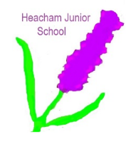

HEACHAM JUNIOR SCHOOL

College Drive, Heacham, PE31 7EJ

TEL: 01485 571013
office@heachamjunior.co.uk
www.heachamjunior.co.uk

PARENTAL CONSENT FORM
FOR REGULAR OFFSITE VISITS & ACTIVITIES

Child DOB Year Group
I hereby agree to my child participating in recognised activities that are organised by the school off the site, for example, environmental studies, swimming, sports matches, joint activities with other schools, visits to local church/library/theatre etc.

I understand that:
- such activities will not often extend beyond the school day, but that if, occasionally, they are likely to do so, adequate advance notice will be given so that I may make appropriate arrangements for his/her safe return home;
- my specific permission will be sought for any out-of-school activities beyond those outlined above and which could involve commitment to extended journeys or times, expense or hazards;
- all reasonable care will be taken of my child in respect of the activity/visit;
- my child will be under an obligation to obey all directions given and observe all rules and regulations governing the visit/activity and will be subject to all normal school discipline during the visit/activity;
- any medical condition, disabilities, or special needs will be notified to the school now and as and when they arise;
- I agree to keep the school/establishment up to date with my emergency contact details.

Please tick box as appropriate:

[ ] I give permission or [ ] I do not give permission

for my child/ward to receive pain relieving medication when appropriate
(one dosage of paracetamol only).

Signature of Parent/Guardian(s) Date
Name of Parent/Guardian(s)
Address
Telephone Mobile
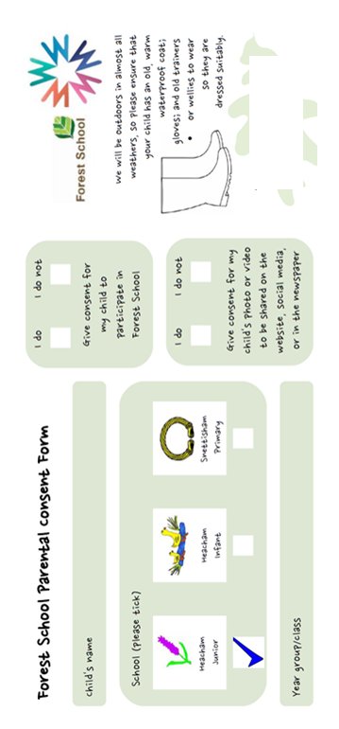
HJS Forest School Parental Consent Form

Child’s Name:

An area of our woodland has been set aside especially for Forest School.



The weather rarely spoils our fun and we will enjoy our woodlands in almost all weathers. Please ensure that on the days that your child is taking part in Forest School they bring an old warm waterproof coat, gloves and old trainers or wellies to wear so that they are dressed suitably.

I give consent for my child to participate in Forest School.

Signed (by parent/carer)
Name of parent/carer

Date

HEACHAM JUNIOR SCHOOL

College Drive, Heacham, PE31 7EJ

TEL: 01485 571013

office@heachamjunior.co.uk
www.heachamjunior.co.uk

Dear Parents,

We allocate all children to one of our Houses:

Caley, Rolfe, Strachan and Ingleby.

It has always been a tradition that families are placed together, so if your child had a parent or a sibling at this school we would like to place them in the same House.

Please return slip below to Mrs Bridge with your application pack.

We look forward to working with you this year. Do not hesitate to get in touch if you have any worries or queries.

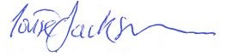
Louise Jackson
Headteacher

------------------------------------------------------------------------------------------
Please return to Mrs Bridge with your application pack

Name:
Has a family member (or previously had a family member in)

please circle:

Caley Rolfe Strachan Ingleby None

Apply online: www.norfolk.gov.uk/neo
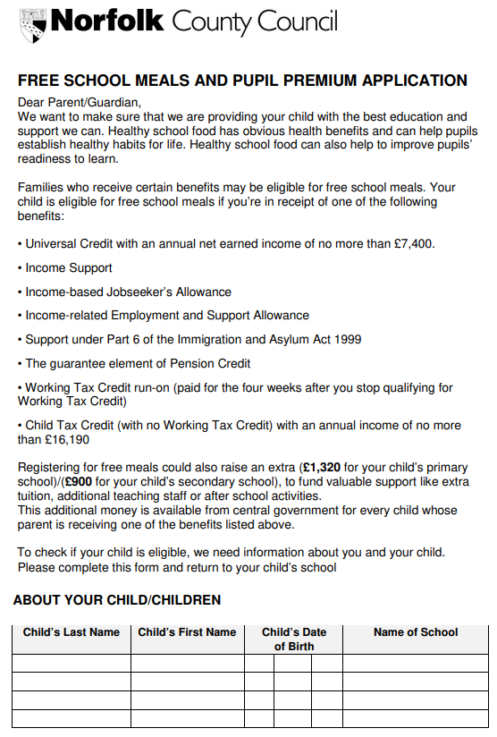
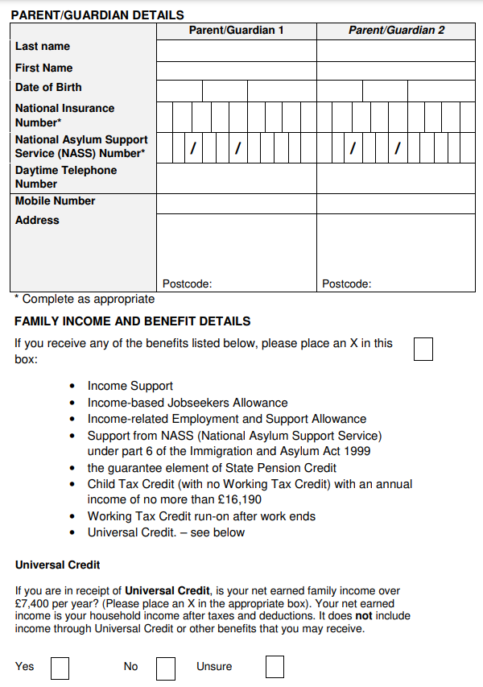

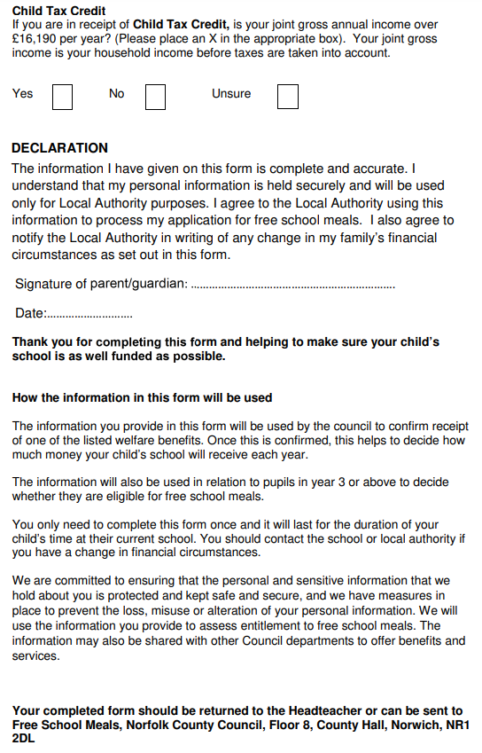

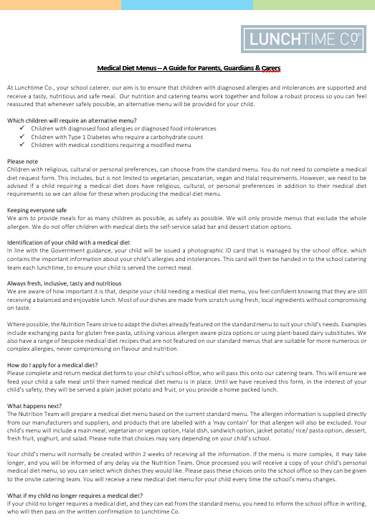
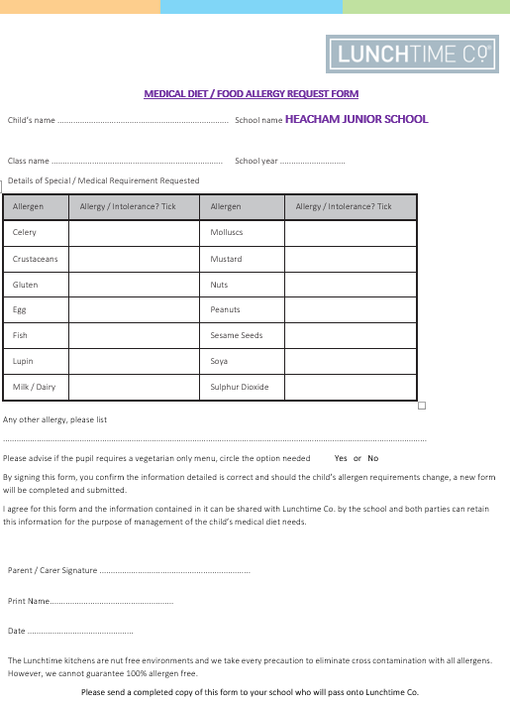
Medical Emergency / Allergy Form

Name of Child: ___________________________________ Class:

My child has the following allergies/medical issues:
__________________________________________________________________________
__________________________________________________________________________

Please list any accommodations your child might need:
__________________________________________________________________________
__________________________________________________________________________

Does your child require medicine/drugs or a personal medical kit? YES / NO
Does your child use an EPI-Pen? YES / NO
Does your child carry their EPI-Pen with them? YES / NO

Emergency Contact Information:
Name: ______________________________________ Phone Number: ________________
Name: ______________________________________ Phone Number: ________________

Medical Emergency Permission:
I give permission for the staff at Heacham Junior to provide First Aid for my child, following the Allergy Action Plan whilst in the care of Heacham Junior School. The school will contact me immediately should my child show any symptoms of an allergic reaction or in the event of a medical emergency and if I cannot be contacted, I give permission for the school to call 999 for emergency treatment for my child whilst in the care of Heacham Junior School.

Signed: ________________________________ Parent/Carer Date: ________________

HEACHAM JUNIOR SCHOOL

College Drive, Heacham, PE31 7EJ

TEL: 01485 571013

office@heachamjunior.co.uk
www.heachamjunior.co.uk

Dear Parents,

Why are we writing to parents of children who have asthma?
I am pleased to advise you that this school takes its responsibilities for pupils with asthma very seriously.

As part of accepted good practice, we are now asking all parents of pupils with asthma to help us to complete a school asthma record for their child. The record will help school staff to ensure that pupils with asthma receive the best possible treatment at all times.

What will happen in school if your child has an asthma attack?
The record will give details of your child’s current treatment and what steps to take if an asthma attack happens at school. In case of asthma emergencies, the school keeps a spacer for use with your child’s metered dose inhaler – providing it fits. (If unsure whether or not your child’s inhaler is compatible please ask your asthma or school nurse).

What are we asking you to do?
Please fill in your child’s details on the asthma record form. You may like to ask your doctor or asthma nurse to help you with this. Also ask your pharmacist to label your child’s inhaler, not just the box which it comes in and ask your doctor (GP) to provide a metered dose inhaler compatible with the spacer for emergency use, if you do not already have one.

What will happen every year?
You will be asked to update the record yearly, but please inform the school in writing if treatment is changed before this time so that the record can be updated.

I look forward to receiving the completed record. Thank you for your co-operation in this important matter. Please return your completed form to me as soon as possible.

Yours sincerely,

Louise Jackson
Headteacher

HEACHAM JUNIOR SCHOOL

College Drive, Heacham, PE31 7EJ

TEL: 01485 571013

office@heachamjunior.co.uk
www.heachamjunior.co.uk

Dear Parents,

Re: School’s Emergency Salbutamol Inhaler

Norfolk County Council has issued guidance on the use of emergency Salbutamol Inhalers in School (September 2014). We have purchased some Salbutamol Inhalers and suitable Spacers for this purpose.

We confirm that the Emergency Salbutamol Inhalers will only be used:

- By children who have been prescribed a reliever inhaler and who are on our Asthma Register.
- Have provided written parental consent to use the school’s Emergency Salbutamol Inhaler (see below).
- Are showing signs of an Asthma Attack.
- Do not have their own inhaler in school.
- Their inhaler has run out or passed its date of expiration.

Children will still need to bring their own inhalers and spacers into school as previous.

If you are happy for your child to use the school’s Emergency Salbutamol Inhaler, please return a copy of this letter with the permission section completed and signed.

Yours sincerely,
Louise Jackson
Headteacher

For Pupils with Medically Diagnosed Asthma Only

In the event of my child displaying symptoms of asthma, and if their inhaler is not available or is unusable, I consent for my child to receive Salbutamol from an emergency inhaler held by Heacham Junior School for such emergencies.

Name of Child:

Signature of Parent:

Name of Parent: Date:

Asthma Record (Care Plan)
Heacham Junior School
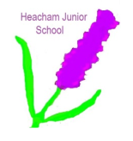
2025-2026
Child’s Full Name:

Child’s Date of Birth:
Parent/Guardian’s Full Name:

Telephone Numbers –  Home:  Work:  Mobile: | Doctor (GP) Name:  Doctor (GP) Telephone:  Asthma Nurse Name:

Known triggers/allergies: | Any other medical problems:

My child’s medication:
Reliever medication (usually blue)

Medication Name:  (e.g. SALBUTAMOL) | Device:  (e.g. diskhaler) | Dose:  (e.g. 1 blister) | When taken:  (e.g. when wheezy, before exercise)

Other Medication:
Most preventers can be taken outside of school hours – check with your GP or asthma nurse.

Medication Name: | Device: | Dose: | When taken:

Emergency Treatment:
In the event of a severe asthma attack I am happy for my child to receive up to 10-20 puffs of the reliever (usually Salbutamol) inhaler via a spacer until they get further medical help.

Signed: (Parent) Date:

Key points for parent to remember:
This record is for your school. Remember to update it if treatment is changed. Remember to check you have enough inhaler doses and that the inhaler is in date and labeled by the pharmacist with your child’s name and dosage details.

HEACHAM JUNIOR SCHOOL

College Drive, Heacham, PE31 7EJ

TEL: 01485 571013

office@heachamjunior.co.uk
www.heachamjunior.co.uk

ATTENDANCE

Dear Parents/Carers,
Reporting your child’s absence – our Safeguarding Responsibilities
We would like to explain that due to our safeguarding responsibilities, we will text families every day that a child is absent if we have not heard from that family on each day (even if you have pre-warned us that they may not be in the following day).
It is a legal requirement to make contact with a parent daily, to ensure that a child is not presumed to be ill when they have, in fact, walked to school and something happen on the way to prevent them arriving. Should an incident occur, a whole day would pass before anyone would know that a child is missing.
If your child is absent, for any reason, please contact school every day, before 8.30am if possible, leaving a short message on our answerphone. There is an option specifically for reporting a child absent.
All schools have annual Safeguarding training and we are committed to ensuring that the safety of your children is in everything we do. We do not mean to annoy or upset by texting and I’m sure that you would support us in our endeavours.
Yours sincerely,
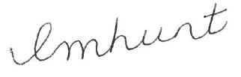

Emma Hunt
Deputy Headteacher

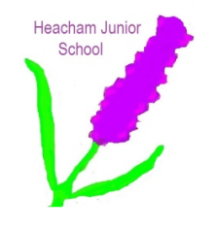

HEACHAM JUNIOR SCHOOL

College Drive, Heacham, PE31 7EJ

TEL: 01485 571013
office@heachamjunior.co.uk
www.heachamjunior.co.uk

Dear Parent/Carer, Sent home each term

Norfolk County Council: Penalty Notices regarding school absence - Guidance for parents
Regular school attendance and parent’s legal responsibilities
At Heacham Junior School our aim is to collaborate with parents to ensure that all our pupils receive the most from their education and reach their full potential.
This guidance is to remind all parents about the law that requires them to ensure that their child attends school regularly. The Government is clear that no child should miss school apart from in exceptional circumstances and schools must take steps to reduce absence to support children’s attainment.
The important legal information – New from 19 August 2024
The Government have introduced a single national threshold for when a penalty notice must be considered by all schools in England. This threshold is 10 sessions (usually equivalent to 5 school days) of unauthorised absence within a rolling 10 school week period. These sessions do not have to be consecutive and can be made up of a combination of any type of unauthorised absence. The period of 10 school weeks can span different terms or school years.
In line with national guidance, the Local Authority (LA) retains the discretion to issue a penalty notice before the threshold is met. This might apply for example, where parents have taken several term time holidays below the national threshold. The LA also retains the discretion to consider going straight to prosecution where appropriate.
A maximum of 2 penalty notices per parent, per child can be issued within a rolling 3-year period. This period will start from the issue of the 1st penalty notice. The national framework also sets out the escalation process which applies to such penalty notices. If the national threshold is met for a third time (or subsequent times) within 3 years, another tool should be used. In Norfolk, where a pupil’s attendance has met the national threshold for a third time within 3 years and the parent/s have already been issued with 2 penalty notices within that period, consideration will be given to prosecution under section 444 of the Education Act 1996, which can result in a criminal conviction and fine of up to £2,500.
A parent includes any person who is not a natural parent but who has parental responsibility for the child or who has care of the child, as set out in section 576 of the Education Act 1996. Penalty notices will usually be issued to the parent/s with day-to-day responsibility for the child’s attendance or the parent/s who have allowed the absence (regardless of which parent has applied for a leave of absence).
Continued/…..

The first penalty notice issued to a parent for a child will be charged at £160 to be paid within 28 days. This will be reduced to £80 if paid within 21 days. Where it is deemed appropriate to issue a second penalty notice, the second penalty notice to the same parent for the same child within 3 years of the first offence, is charged at a flat rate of £160 and is payable within 28 days. There is no reduced sum available in this instance.

Part payments or payment plans are not acceptable, and fines must be paid in full within 21 or 28 days, at the rate specified within the penalty notice. There is no right of appeal against a penalty notice.

Requests for leave of absence
Working together to improve school attendance advises all schools that they should only grant a leave of absence during term time in exceptional circumstances, considering each request on a case-by-case basis. If a leave of absence is granted, it is for the headteacher to determine the length of time the pupil can be away from school. Although we recognise the value and benefits of family holidays, it is unlikely a leave of absence will be granted for a family holiday as the Government ‘does not consider a need or desire for a holiday or other absence for the purpose of leisure and recreation to be an exceptional circumstance.’
Requests for leave must be made in advance, otherwise schools will be unable to consider your individual circumstances and the absence will be recorded as unauthorised. Headteachers are not obligated to reconsider authorising leave if an application was not made in advance.
Support with ensuring regular school attendance
If you require any support with ensuring your child’s attendance, please contact the school.

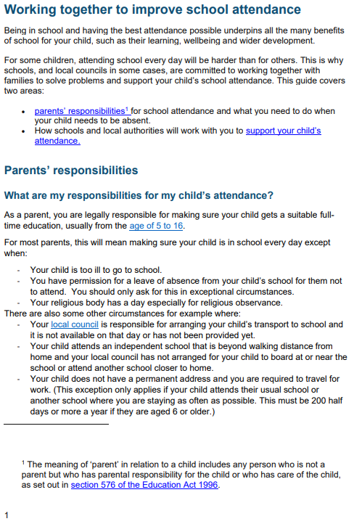

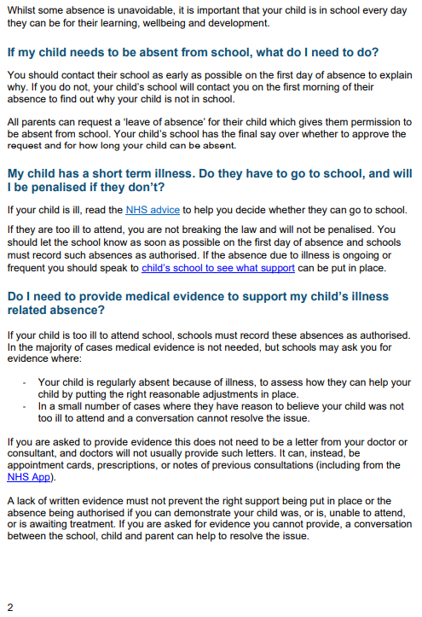

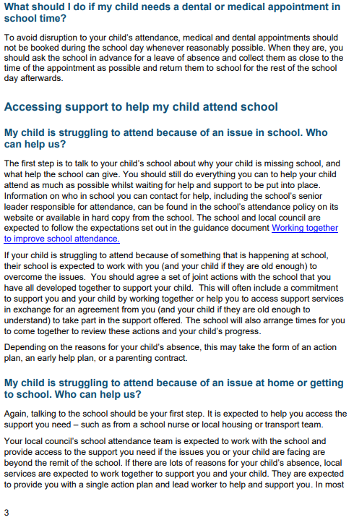

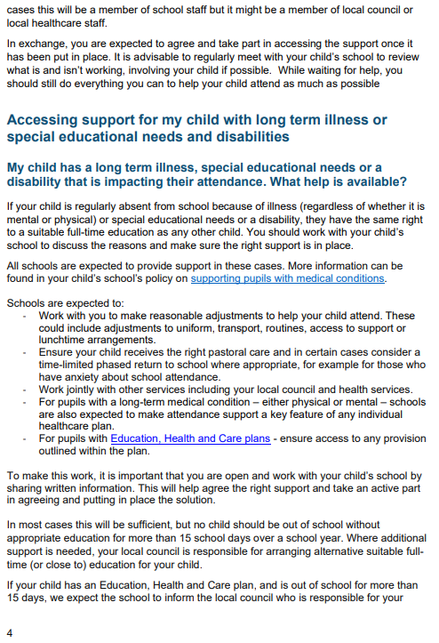

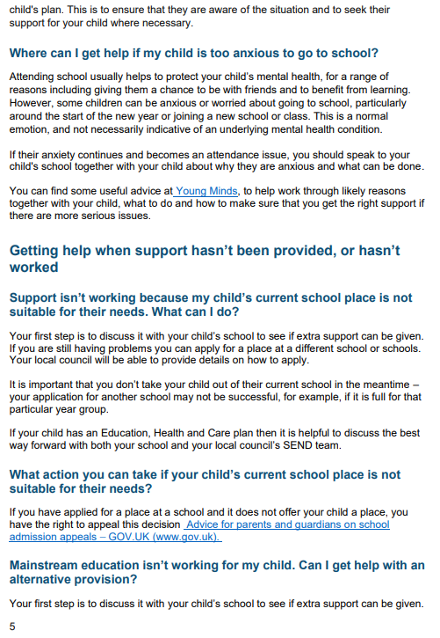

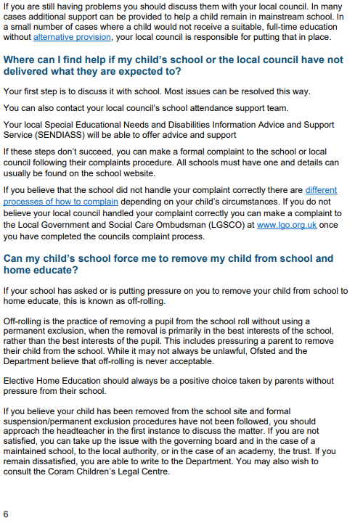

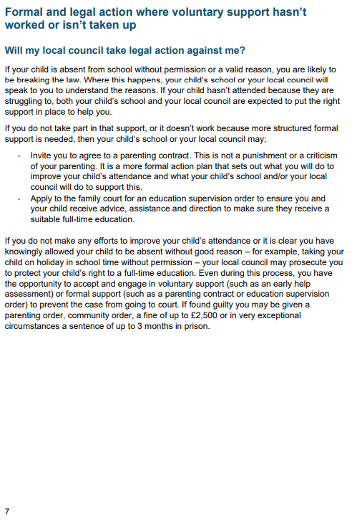

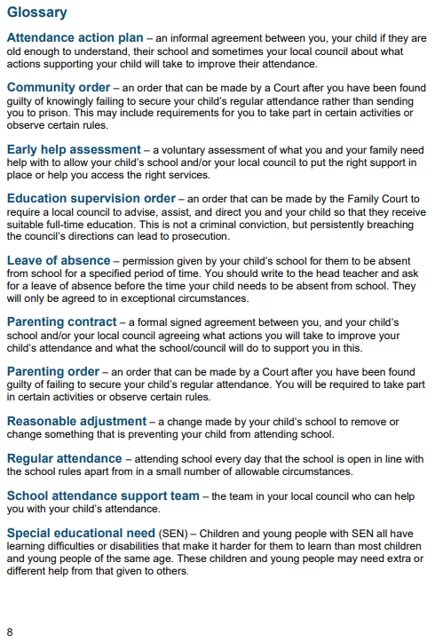

EXAMPLE MENUS ONLY

SUBJECT TO CHANGE
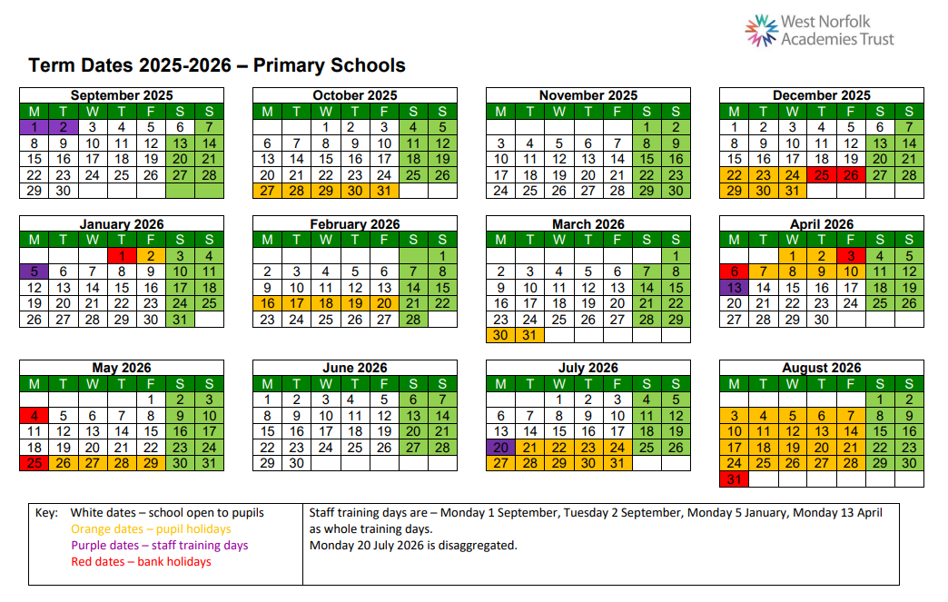
Uniform:
Our supplier in King’s Lynn holds stock of the items below. Please contact them for current prices. They will deliver your uniform order to school.
Book bags, PE Tops, Sweatshirts, Polo Shirts, Cardigans, PE Bags, Fleeces.

Minuteman Press (King’s Lynn)
12 Campbells Business Park, Campbells Meadow, King’s Lynn, PE30 4YR
Tel: 01553 661103
Email: kingslynn@minutemanpress.com

The children are encouraged to wear school uniform as it promotes a feeling of identity and pride in the school.

The West Norfolk Academies Trust believes that uniforms are an important element in nurturing a sense of identity and responsibility.
All Trust academies have a uniform which is accessible to all pupils and their families and which represents value for money. The Trust and its academies are committed to supporting families experiencing hardship to ensure that all pupils can comply with their individual academy’s Uniform Procedures. If you would like further information on support please contact the office or speak with your child's teacher.

Uniform consists of:
- Charcoal grey skirt, charcoal grey pinafore dress, charcoal grey trousers.
- Sky blue polo shirt or polo shirt (tucked in) with school logo, available from Minuteman Press in King’s Lynn.
- There is a choice between a burgundy cardigan or sweatshirt both with the school logo, available from Minuteman Press in King’s Lynn. (Sweatshirts are expected to be hung up when not being worn and not tied around the children's waist).
- Blue summer dresses and charcoal grey shorts are permitted in the summer.
- Socks should be white or grey and tights must be grey
- All children should wear black school shoes, trainers are not permitted. If your child wears shoes with laces please ensure that they are able to tie them up.

All children need a bag containing the following clothing for P.E.
- Sky blue P.E. t-shirt with school logo, available from Minuteman Press in King’s Lynn
- Navy or Black Shorts
- Navy or Black Track Suit
- Trainers for outdoor P.E. plimsolls for indoor P.E.

If you would like to include an old t-shirt or shirt for children to wear during art projects in order to protect their uniform this is welcomed.

Please label ALL items of clothing and personal belongings with your child’s name and class. This will help to identify their items more easily if they lose them.
Jewellery must not be worn to school. Small studs in pierced ears are permitted but must be removed for swimming and P.E. lessons.
We expect a high standard of dress from Heacham Junior School children. We consider it important to show value and respect for our school family. Extremes of fashion in hairstyles or clothing are not suitable for general school wear. We ask that hair is tied up for PE lessons and that clips, bows, bobbles and headbands are in school colours and small.
Can we please ask that children are dressed properly for the weather. If it is cold and wet please supply your child with a warm coat and wellies.
In the summer we recommend children have a hat and have sun cream applied BEFORE they come to school.

UNIFORM SUPPLIER INFORMATION
Minuteman Press (King’s Lynn) will deliver your uniform to school.
12 Campbells Business Park, Campbells Meadow, King’s Lynn PE30 4YR
Tel: 01553 661103
Email: kingslynn@minutemanpress.com

HEACHAM JUNIOR SCHOOL

College Drive, Heacham, PE31 7EJ

TEL: 01485 571013

office@heachamjunior.co.uk
www.heachamjunior.co.uk

18th December 2023

CHARGES FOR MORNING DROP-IN

Dear Families,

Our current charge for morning drop-in has not changed since we started 4 years ago.

From April 2024, we will be charging the following rates, in line with other providers in Norfolk. This will still include a breakfast bar, fruit or a pastry.

Per session - flat rate of £3.50 per child per session
Siblings - 15% discount for siblings (£2.97 per session)
Staff children - 50% discount (£1.75 per session)

We can no longer offer free sessions.

This rate will be applied from 1st April 2024.

Yours sincerely,
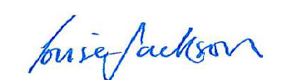

Louise Jackson
Executive Headteacher

