EASTER JOLLY JARS
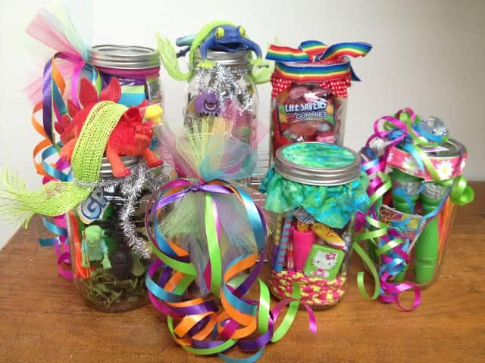
Please help with school fundraising by filling a jam jar with something that will appeal to boys and girls.
For example: sweets, pencils, rubbers, stickers, notebooks, crafty bits etc. (please ensure they don’t contain anything unsuitable for smaller children).
The jars can be decorated with an Easter theme.
Please bring into school by Monday
9th March so they can be sold at the
Easter Eggstravaganza
Thurs 12th March
If you would like any empty jars, there are lots at school in the office, help yourself!



