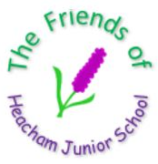
FRIENDS OF HEACHAM JUNIOR SCHOOL


EASTER
EGGSTRAVAGANZA!

Wed 12/03/26 - 3.30pm to 4.30pm

Lots of stalls and games:


- Socks on the washing line
- Dippy Egg
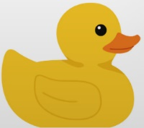
- Quack Shot

- Jolly Jar Tombola
- Bunny Bowling
…AND MORE!

Year 6 will also be running stalls in aid of two Children’s Charities



- SPLAT THE TEACHER

- Bake Sale



